Music Player

<!DOCTYPE html>
<html>
<head>
<meta name="viewport" content="width = device-width, initial-scale = 1" />
<link
rel="stylesheet"
href="https://code.jquery.com/mobile/1.4.5/jquery.mobile-1.4.5.min.css"
/>
<script src="https://code.jquery.com/jquery-1.11.3.min.js"></script>
<script src="https://code.jquery.com/mobile/1.4.5/jquery.mobile-1.4.5.min.js"></script>

<style>

</style>
</head>

<body>
<div data-role="page" >
<div data-role="header" data-theme="b">
<h2>Music player</h2>
</div>
<div data-role="content" data-theme="a">
<audio controls>
<source src="kaka.mp3" type="audio/mpeg">
Your browser does not support our music.
</audio>
</div>

<div data-role="footer" data-theme="c">
<h4>Footer</h4>
</div>
</div>
</div>
</body>
</html>
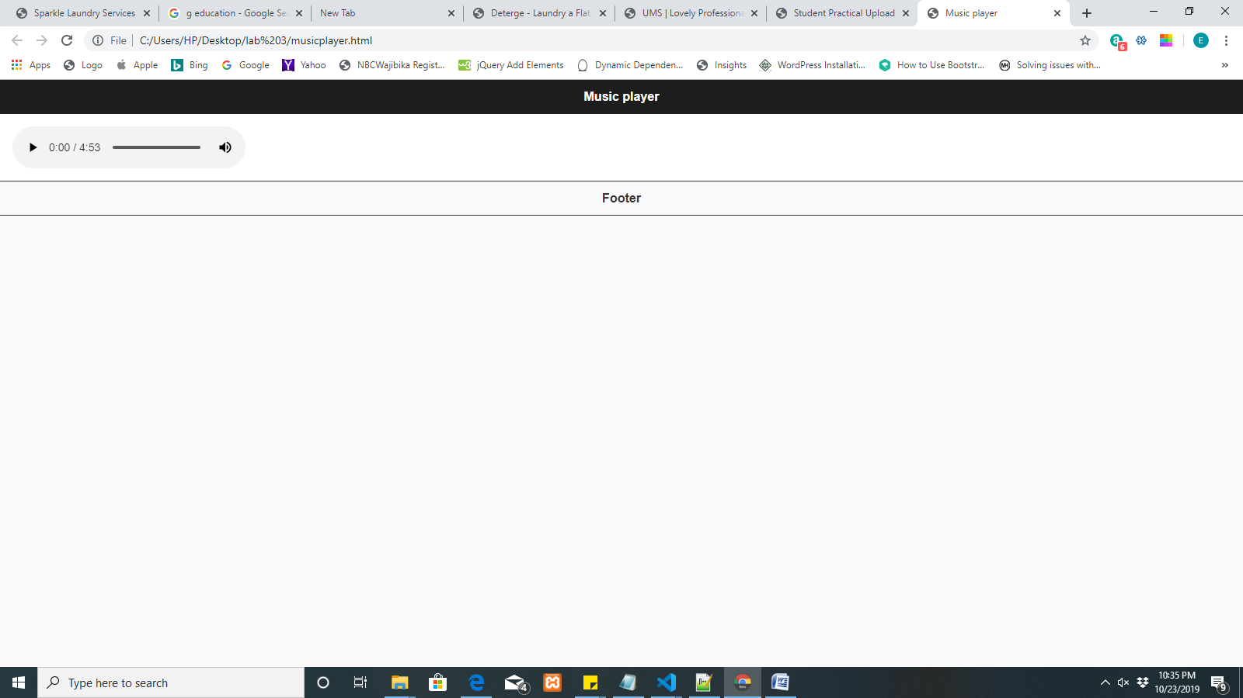

Latitude & longitude

<!DOCTYPE html>
<html>
<head>
<meta name="viewport" content="width = device-width, initial-scale = 1" />
<link
rel="stylesheet"
href="https://code.jquery.com/mobile/1.4.5/jquery.mobile-1.4.5.min.css"
/>
<script src="https://code.jquery.com/jquery-1.11.3.min.js"></script>
<script src="https://code.jquery.com/mobile/1.4.5/jquery.mobile-1.4.5.min.js"></script>

<style>

</style>
</head>

<body>
<div data-role="page" >
<div data-role="header" data-theme="b">
<h2>Music player</h2>
</div>
<div data-role="content" data-theme="a">
<p>Click the button to get langitude and latitude.</p>

<button onclick="getLocation()">click here</button>

<p id="demo"></p>

<script>
var x = document.getElementById("demo");

function getLocation() {
if (navigator.geolocation) {
navigator.geolocation.watchPosition(showPosition);
} else {
x.innerHTML = "Geolocation is not supported by this browser.";
}
}

function showPosition(position) {
x.innerHTML =
"Latitude: " +
position.coords.latitude +
"<br>Longitude: " +
position.coords.longitude;
}
</script>
</div>

<div data-role="footer" data-theme="c">
<h4>Footer</h4>
</div>
</div>
</div>
</body>
</html>
